Lab #8 b part

Task #10:

Code

#include<iostream>

using namespace std;

int main()

{

for (int i = 5; i >= 1; i--) /*Here we are using three for loop, first for Loop for the Number of rows */

{

for (int j = 5; j > i; j--) /*Second Loop is for spaces*/

{

cout << " ";

}

for (int k = 1; k <= i; k++)

{

cout << "*";

}

cout << endl;

}

system("pause");

return 0;

}

Output

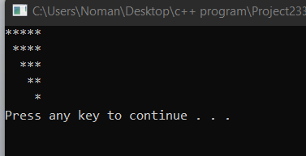

Task 11

Code:

#include<iostream>

using namespace std;

int main()

{

for (int i = 1; i <= 4; i++)

{

for (int j = i; j < 4; j++)/*This for loop is for spaces*/

{

cout << " ";

}

for (int k = 1; k <= (2 * i - 1); k++) /*This for loop is too display stars*/

{

cout << "*";

}

cout << endl;/*This will end line After each row */

}

system("pause");

return 0;

}

Output

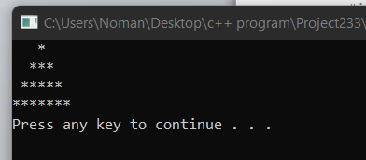

Task #2

Code

#include<iostream>

using namespace std;

int main()

{

int a, b, lcm; /*Here we are taking two varibles as a input*/

cout << "Enter the value of a:";

cin >> a;

cout << endl;

cout << "Enter the value of b:";

cin >> b;

cout << endl;

if (a > b) /*this is the condition for Lcm*/

{

lcm = a;

}

else

{

lcm = b;

}

do

{

if(lcm%a==0 && lcm%b==0)

{

cout << "Lcm of a and b is =" << lcm << endl;/*This will be ouput of lcm*/

break;

}

lcm++;

} while (true);

system("pause");

return 0;

}

**Output**

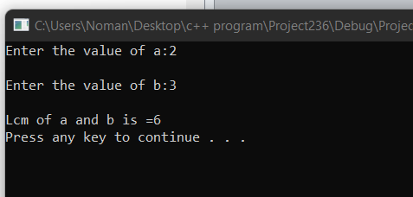

Task #9

#include<iostream>

using namespace std;

int main()

{

for (int i = 1; i <= 5; i++)

{

for (int k = 5 - i; k > 0; k--)

cout << " ";

for (int j = 1; j <= i; j++)

{

cout << "*";

}

cout << endl;

}

system("pause");

return 0;

}

Output

